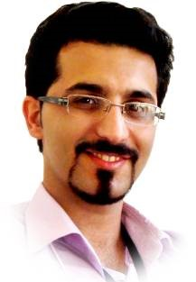
pu Hamed Aghapanah Roudsari
___Personal Background
________________Educational Background | scholar    0000-0001-5521-5410  link
  
  40.1 plate number, Shahin Alley, Roudsar, 4481833539, Guilan,Iran
  
  (+98) 13-4262-7446  (+98) 911-143-9149
  
  H.aghapanah@gmail.com, H.aghapanah@modares.ac.ir, H.aghapanah@IEEE.org
  
  https://hamedaghapanah.com H.aghapanah 
  Sex : Male | Date of birth : 28/03/1986 | Nationality : Iranian | Marital status : Married
- 2018 – 2024 : Ph.D Bioelectrical Engineering GPA: (17.33/20), Isfahan University of Medical Sciences.  Thesis: Dense Field Estimation of Ventricle Wall Motion Using a Combined Approach of Active Mesh and Deep Learning in 4D Cardiac MRI. (19.38/20)  Supervisor Professor Kermani (kermani@mui.ac.ir ) and Dr Reza Rasti(r.rasti@ieee.org). | 
- 2009 – 2011: M. Sc, Bioelectrical Engineering GPA: (18.33/20)  Tarbiat Modares University, Tehran, Iran.  Thesis: Using Texture Analysis To Diagnose Skin Cancer (18.9 /20)  Supervisor: Professor Hassan Ghassemian,( ghassemi@modares.ac.ir) | 
- 2004-2008: B. Sc, Electrical Engineering GPA:(16.19/20)  University of Guilan, Rasht, Guilan, Iran., 2nd Ranked (ranked 2 out of 60 students)  Thesis: Sweeper Robot using AVR (17.5/20)  Supervisor: Dr. Hamed Mojalali ,( mojallali@guilan.ac.ir) and Professor Mehrgan Mahdavi | 
________________Researching , Teaching & Working Experiences

- 2018-2025: Secretary of Isfahan Cardiac Image Processing Core, Secretary of Medical Engineering Scientific Association of Isfahan University of Medical Sciences.
- 2018 - 2024: the manager of the artificial intelligence department of puyesh Sanat Raili Company in the field of intelligent processing and systems based on Android and IOS.
- 2018- 2021: Responsible for R&D of Poya Nik Banyan Sharif in the field of signal processing and AI.
- 2014 - 2024: technical officer, Bahar Teb Gilan Company, Orthopedic field (repairs and sales of orthopedic equipment).
- 2008 - 2014: Instructor of medical equipment, medical informatics, Tonkabon Azad University, industrial control courses, specialized language and electrical safety at Siahkol University, specialized language, biophysics, introduction to medical engineering and analysis of linear systems at Rahman and Kasri universities Ramsar.
- 2007-2008: Cooperation as the medical equipment manager of Porsina Hospital in Rasht, Imam Sajjad Naja and Ahmadinejad Hospital in Ramsar.
- 2007: Collaboration with the salt pepper noise reduction project of satellite images of Sa Iran Satellite Research Center (SRC), Tehran, Nobnayad (deductible for elite services).
- 2006: Repair engineer of Behsaz Teb company, mobile CT products and kidney stone crusher
________________ Research Interests

Deep Learning, Machine Vision, Video and Signal processing on Embedded Systems.

________________ Honors and Awards
- 2018: 4rd ranked in Ph.D annual Iranian exam of Iran National Universities 1st ranked in Ph.D annual Iranian exam of Azad Universities and 7th ranked in Ph.D exam Iranian governmental Universities ( International elite) .
- 2008: Appreciation award 5th in Iran Open Robotic Competition, Ghazvin, Iran.
- 2003: Honor Student in Math Olympiad of Iranian Young Mathematicians institute (5th rank).
- 2001-2004: 1st rank student in the field of Mathematics and Physics GPA 18.78/20.
________________Books

[A] Saleh zamani Nejhad, H. Aghapanah, “Bio-medical Engineering (Principles Of Operation And Maintenance Of Medical Equipment)”, Science Press Publishing Association, Fall 2014.(link1, link2)

[B] H. Aghapanah, S. R. Aale Nabi,” English In Medical Engineering ”, Amirkabir Jahad Press, Jan 2018 (link1).

________________ Journal Publications
[1] H. Aghapanah, R. Rasti, S. Kermani, F. Tabesh, H. Y. Banaem, H. P. Aliakbar, H. Sanei, and W. P. Segars, “CardSegNet: An Adaptive Hybrid CNN-Vision Transformer Model for Heart Region Segmentation in Cardiac MRI,” Comput. Med. Imaging Graph., p. 102382, 2024. (link1).CiteScore: 10.7, Impact Factor: 5.4 ,Q1
[2] H. Aghapanah, Rasti, Reza, Tabesh, Faezeh, Pouraliakbar, Hamidreza, Sanei, Hamid, Kermani, Saeed,” MECardNet: A novel multi-scale convolutional ensemble model with adaptive deep supervision for precise cardiac MRI segmentation”, Biomedical Signal Processing and Control, 2025 (link1). CiteScore: 9.8, Impact Factor: 4.9 ,Q1.
[3] R. Esmaeili, H. Aghapanah, H. Ghasemian, M. Ashouri, M. Nakhaei pour, A. Alboghobeish, M. jalali, N. Ghotbi, and S. V. Esmaeili, “Hearing loss prediction equation for Iranian truck drivers using neural network algorithm,” WORK, p. 10519815241295944, Nov. 2024. Impact Factor: 1.7 Q2
[4] E. Mohammadi, S. Kermani, M. Nourian-Zavareh, A. Zare, H. Aghapanah-Roudsari, M. Samieinasab, and H. Sanei, “A New Approach of Phonocardiogram Analysis for Screening Some of Cardio-vascular Diseases Based on Deep Learning,” J. Isfahan Med. Sch., vol. 40, no. 661, pp. 109–114, 2022, Impact Factor: 0.1 Q4 (link).
[5] H. Aghapanah, H. Ghassemian,” Unsupervised Skin Cancer Detection By Combination Texture And Shape Features In Dermoscopy Images”, Journal of Intelligent Systems in Electrical Engineering, Tehran, 2013 (link1). (Persian).
[6] H.Aghapanah, M. Chubin, and M. Mohammadi, “Comparing Classic Machine Learning with Deep Learning for Stress Detection Using Wearable Sensors,” Comput. Sci. Eng., 2024. (link1).

[00] H. Aghapanah, Ehsan Mohammadi, Reza Rasti, Saeed Kermani1,” Fusion Deep Learning Models and Meta data in Classification of Dermoscopic images”, Computer Methods and Programs in Biomedicine Update, 2025. (Under review).
[00] H.Aghapanah, Ehsan Mohammadi, Saeed Kermani, Morteza Chubin, " DeepPCA : A Novel PCA-based Classification of Signal in P300 Speller ", IEEE Transactions on Medical Robotics and Bionics,2025 (link). (Under review).

________________ Conference Publications
[7] H. Aghapanah, R. Rasti, and S. Kermani, “CardioTrackNet: A Hybrid Active Mesh and PWC Model for Enhanced Cardiac MRI Motion Analysis and Visualization BT ”- Proceedings of the Iranian Conference on Biomedical Engineering (ICBME 2024), 2024.
[8] H.Aghapanah, Ali Saeeidi Rad, Reza Rasti "A Survey of Deep learning in Advancing Steel Industry Standards" 2024 20th CSI International Symposium on Artificial Intelligence and Signal Processing (AISP)(link)
[9] H.Aghapanah, Maryam Mohammadi, "Stress detection using wearable sensors", The 7th National Conference and the 1st International Conference on Distributed Computing and Big Data Processing (1401) (link)
[10] Mohia Darabi, Morteza Chobin, H.Aghapanah, Ramin Afrah, "Investigation of classical learning networks in P300 component classification for use in brain-computer interface systems", presented at the 5th National Conference of New Technologies in Electrical, Computer and Mechanical Engineering of Iran (1401) (link)
[11] Morteza Chobin, H.Aghapanah, "Vehicle license plate recognition using deep learning techniques and YOLO 4 algorithm" presented at the 8th International Conference on Electrical, Computer and Mechanical Engineering (link)
[12] H.Aghapanah, Hassan Ghasemian, "Local PCA method to remove salt and pepper noise from satellite images", 10th Iran Machine Vision and Image Processing Conference, Isfahan University of Technology, November 2017, (link)
[13] H. Aghapanah, H. Ghassemian, "Face Recognition and Tracking Methods Based on the Python", Second National Conference on Modern Approaches in Computer and Electrical Engineering, Iran, May 2016, COI: BPJ02_190 (link1).
[14] Sahar Alipour, H.Aghapanah and Mohammad Reza Yamghani, "Anonymization of medical images in order to hide patient information", Second National Conference on New Approaches in Computer and Electrical Engineering (2015), COI code of the article: BPJ02_256 (2015) (link).
[15] H.Aghapanah, Zahra Sayedi, "Automatic real-time recognition of car license plates using compression method", First National Conference of New Approaches in Computer and Electrical Engineering (2014) ()
[16] H. Aghapanah, H. Ghassemian, "Combination Shape and Texture Features in Skin Cancer Diagnosis", 19th Iranian conference on Biomedical Engineering, Amirkabir university, page 31-36, Iran, 2013 (link1)().
[17] H. Aghapanah, H. Ghassemian, "Finding Structure In Methods By Using Fisher Discrimination To Classify Dermoscopy Images", Fifteenth Iranian Student Conference on Electrical Engineering, Iran, 2013 (link).
[18] H. Aghapanah, H. Ghassemian, "Dual Feature and Decision Fusion In Texture Classification", Fifteenth Iranian Student Conference on Electrical Engineering, Iran, 2012 (link).
[19] H. Aghapanah, H. Ghassemian, A. Ahadpour Shal, "Fusion Features and Decisions in Diagnosis of Pigmented Skin Lesions". Electrical World Academy of Science, Thailand, 2011 (link).
[20] H. Aghapanah, H. Ghassemian, A. Ahadpour shal, "Methodological Approach to the Classification of Dermoscopy Image By Using Adaptive Power Spectral Density", in Proc Electrical World Academy of Science, Thailand, 2011 (link).
[21] M. Chubin, H. Aghapanah, H. Ghassemian, A. Ahadpour shal, "The fusion of multi-spectral and panchromatic images using wavelet fusion methods: principal component analysis, IHS, a high-pass filter Gram-Schmidt". in Proc Electrical World Academy of Science, Thailand, 2011.
[22] A. Tahmasbi, F. Saki, H. Aghapanah, S. B. Shokouhi, "A Novel Breast Mass Diagnosis System Based on Zernike Moments as Shape and Density Descriptors", in Proc. IEEE, 18th Iranian Conf. on Biomedical Engineering (ICBME'2011), pp. 100-104, Iran, 2011 (link).
[23] H.Aghapanah and Mina Basirat, "Fingerprint image classification using Minusha and Wavelet features integration", 5th international conference on achieving new methods in electrical engineering, Kashan, Iran 2013 (link).

________________Computer and Hardware Skills
■ OS: Windows, Linux, ■ HLL: Python, Ruby, C/C++, VB, Assembly (Z80)
■ IDE: MATLAB, LabVIEW 5-7, Code Composer Studio, KEIL, BASCOM, CODVISION, Unity, Unreal Engine (Beginner)
■ Databases: MySQL, MongoDB ■ Embedded: Jetson, Raspberry Pi, AVR, 8051, Z80, PLC (Step5, Step7), FPGA (Beginner)
■ Tools & Frameworks: Git, CSS, HTML, Bootstrap 5, JavaScript, React, AngularJS, Node.js, Django, Laravel, Kotlin
■ Cloud & AWS: AWS Cloud, AWS Serverless, AWS Machine Learning (AWS ML)
________________Language Skills
- IELTS 6 ( S 6,L 5.5, W 5.5, R 5.5) |Date 28/12 2016 | 16IR003026AGHH026A| ADD IELTS test center
________________References
Dr. H. Ghassemian (Professor), EE Department, Univ. of Tarbiat Modares, Iran  Email: ghassemi@modares.ac.ir, (Home page) | 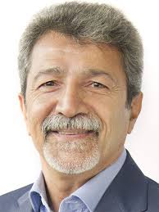 | Dr. Saeed Kermani (Associate Professor),EE Department, , Univ. of Isfahan, Iran.  E: kermani@med.mui.ac.ir, (Home page) | 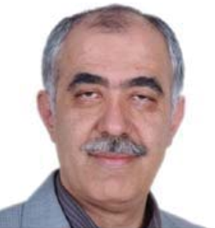
Dr. M. Mahdavi (Professor), Computer Department, Univ. of Victoria University Sydney, Australia  Email: mahdavi@guilan.ac.ir, (Home page) | 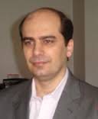 | Dr. R.Rasti (Assistant Professor),Biomedical Department, Univ. of Isfahan University, Iran , Research Collaborator at Duke.  Email: r.rasti@eng.ui.ac.ir, (Home page) | 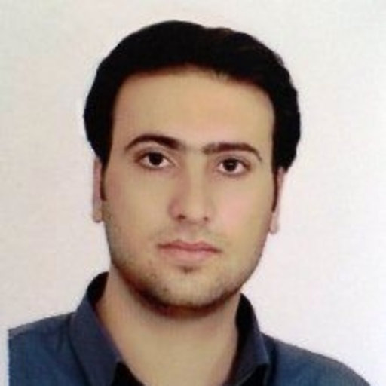

________________ Two books published

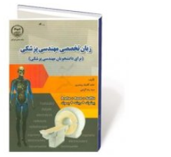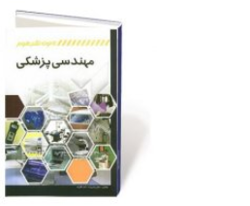
________________ Certificate in Medical Engineering Repair Course

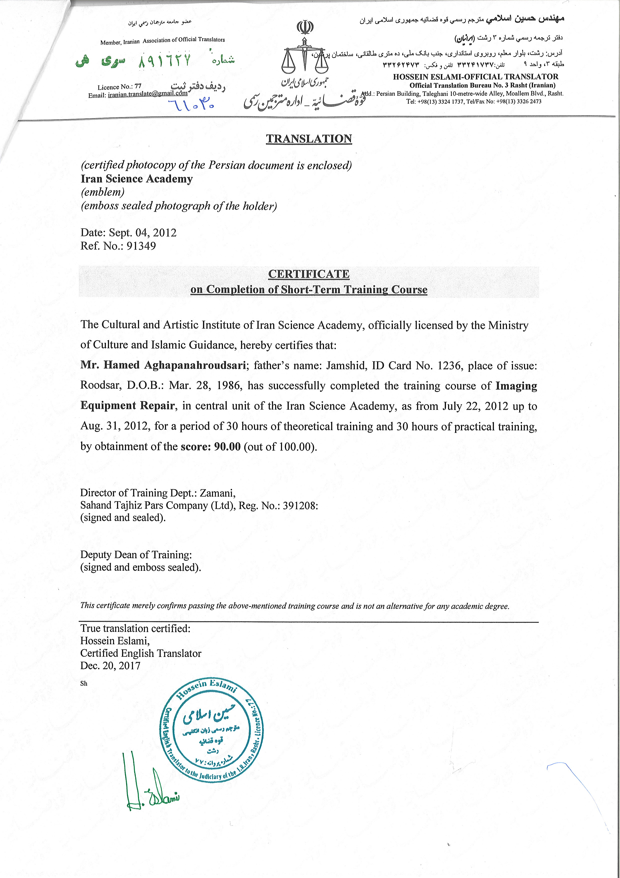

[1] H. Aghapanah, R. Rasti, S. Kermani, F. Tabesh, H. Y. Banaem, H. P. Aliakbar, H. Sanei, and W. P. Segars, “CardSegNet: An Adaptive Hybrid CNN-Vision Transformer Model for Heart Region Segmentation in Cardiac MRI,” Comput. Med. Imaging Graph., p. 102382, 2024.
[2] H. Aghapanah, R. Rasti, F. Tabesh, H. Pouraliakbar, H. Sanei, and S. Kermani, “MECardNet: A novel multi-scale convolutional ensemble model with adaptive deep supervision for precise cardiac MRI segmentation,” Biomed. Signal Process. Control, vol. 100, p. 106919, 2025.
[3] R. Esmaeili, H. Aghapanah, H. Ghasemian, M. Ashouri, M. Nakhaei pour, A. Alboghobeish, M. jalali, N. Ghotbi, and S. V. Esmaeili, “Hearing loss prediction equation for Iranian truck drivers using neural network algorithm,” WORK, p. 10519815241295944, Nov. 2024.
[4] E. Mohammadi, S. Kermani, M. Nourian-Zavareh, A. Zare, H. Aghapanah-Roudsari, M. Samieinasab, and H. Sanei, “A New Approach of Phonocardiogram Analysis for Screening Some of Cardio-vascular Diseases Based on Deep Learning,” J. Isfahan Med. Sch., vol. 40, no. 661, pp. 109–114, 2022.
[5] H. Aghapanah Rudsari and H. Ghassemian, “Unsupervised Skin cancer detection by combination of texture and shape features in dermoscopy images,” Comput. Intell. Electr. Eng., vol. 5, no. 1, pp. 1–12, 2014.
[6] H. Aghapanah Roudsari, M. Chubin, and M. Mohammadi, “Comparing Classic Machine Learning with Deep Learning for Stress Detection Using Wearable Sensors,” Comput. Sci. Eng., 2024.
[7] H. Aghapanah, R. Rasti, and S. Kermani, “CardioTrackNet: A Hybrid Active Mesh and PWC Model for Enhanced Cardiac MRI Motion Analysis and Visualization BT - Proceedings of the Iranian Conference on Biomedical Engineering (ICBME 2024),” 2024.
[8] H. Aghapanah, A. S. Rad, and R. Rasti, “A Survey of Deep learning in Advancing Steel Industry Standards,” in 2024 20th CSI International Symposium on Artificial Intelligence and Signal Processing (AISP), 2024, pp. 1–7.

